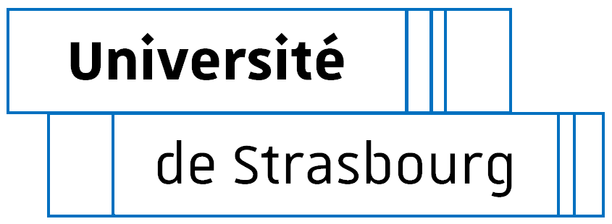
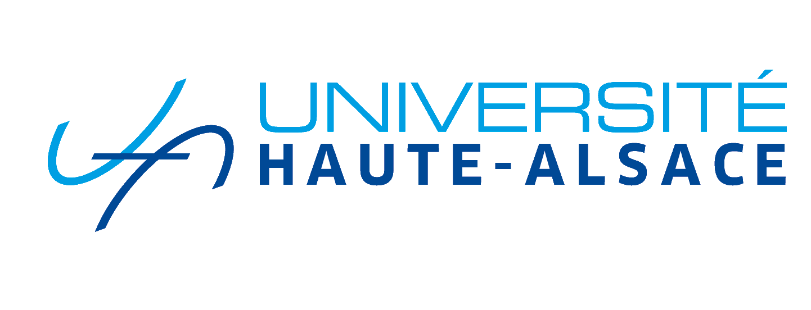

DOCTORAL COLLEGE - UNIVERSITY OF STRASBOURG
Individual training agreement

Between:
- The doctoral student
- Title, first name, name: [title, family name, first name] if applicable, usual name: [usual name]
- Date, place and country of birth: on [date], in [place + country]
- Nationality: [nationality]
- INE No.: [INE]
- Address: [home address]
- Mobile phone number: (Mob. No.)
Hereinafter referred to as "the doctoral student" on the one hand.
And
- The thesis supervisor
- Title, first name, family name: Title, family name, first name]
- Academic title: Academic title
- Research Unit: RU
- Quota of supervision:
Hereinafter referred to as "the thesis supervisor" on the other hand.
- Co-supervisor, if applicable:
- Title, first name, family name: Title, family name, first name]
- Academic title: Academic title
- Research Unit: RU
- Quota of supervision:
Hereinafter referred to as "the co-thesis supervisor" on the other hand.
- The thesis supervisor in a company or private organization, if applicable:
- Title, first name, last name:
- Job title:
- Company/organization:
- Quota of supervision:
Hereinafter referred to as “company supervisor” on the other hand.
Under the aegis of:
- The Research Unit:
- Label - Name of the research unit
- Director [Family name + first name of the director]
Hereinafter referred to as the "Research Unit" on the other hand.

- The Doctoral School:
- École doctorale des sciences juridiques (ED 101)
- Director / Co-Director: [Title - First name - family name]
Hereinafter referred to as "the Doctoral School" on the other hand.

Hereinafter jointly referred to as the PARTIES.

- Having regard to article L612-7 of the Education Code and articles L412-1 and L412-2 of the Research Code,
- Having regard to the Decree of 25 May 2016 laying down the national training framework and the procedures leading to the award of the national doctoral diploma,
- Having regard to the doctoral charter of the University (Strasbourg or UHA)
- Having regard to the internal regulations of the Doctoral School,
- (If applicable) Having regard to the international co-supervision agreement between the University .... and [denomination of partner institution, city, country]

The PARTIES have agreed the following:
Article 1: The administrative framework
The doctoral project is prepared, in line with all the general conditions in force at the University (Strasbourg or UHA) and specific conditions at the Doctoral School as part of a University doctoral degree registration in (Strasbourg or UHA) as of the academic year [Date 1st Adm Registration]. If applicable: The doctoral project is conducted within the framework of an international co-supervision of theses, with [denomination of partner institution, city, country].
The research project has the following characteristics:

- Title of the thesis: [title of thesis]

- Doctoral field: [field]

Hours of work and remuneration dedicated to doctoral studies
☐ full time / remuneration dedicated to the preparation of the doctorate (e.g.: doctoral contract)
☐ part time / remuneration not dedicated to the preparation of the doctorate (e.g.: secondary school teacher)
☐ other case: specify

Remuneration from [start date] to [end date] included.
- Position: [type of contract]
- Employer: [employer]
- Source of the funding dedicated to the preparation of the doctorate: [source of funds]

If remuneration is less than 36 months, it is imperative to indicate the projected financing plan (source and duration of funding):

Here, each PhD student can indicate his personal resources (family support, credit...).

Article 2: Research project planning and related arrangements
The doctoral student’s integration into the Research Unit is in accordance with the rules of the research unit and the doctoral charter.
Summary of the research project (10 lines maximum):

Projected schedule of the research project: (indicate the main scientific steps and possible scientific mobility)
In France, a PhD project in law or political science can last up to 5 or 6 years, in part because of the requirements for an academic career.

[Projected schedule]

Methods of supervision, follow-up of training and progress of doctoral research (methods and means) - reference may be made to the doctoral college's regulations:
- Organisation of doctoral student follow-up (indicate the supervisors, the frequency of meetings with the supervisors and (if applicable) other persons involved in the supervision, and the projected delivery schedule of progress reports by the doctoral student)

- Monitoring committee
- The monitoring committee meets yearly from the 1st year of PhD, according to the Decrees of 25 May 2016 and 26 August 2022, the rules of the Unistra Doctoral College and the internal regulations of the Doctoral school.
Composition of the committee:
- Family name, first name, academic title, home institution, research unit
- Family name, first name, academic title, home institution, research unit
- …

- Prerequisites for the thesis defence
- The required doctoral course is approved according to the Decree of 25 May 2016 and the internal regulations of the Doctoral School.
Material (working environment, specific safety conditions, access to equipment, etc.) and financial conditions (financial support for operating and mission expenses) of the research project:
Reference may be made to the internal regulations of the Research Unit, where applicable, for material conditions. The issue of financial support for research stays, participation in seminars and conferences will be discussed.

Research will be conducted primarily in the Unistra academic libraries. If needed, the doctoral student will benefit from access to the resources and equipment from the Research Unit.
If a research stay is necessary, in France or in another country, the doctoral student can apply for funding from the Research Unit and the Doctoral School, following their respective regulations, and in agreement with the thesis supervisor.

Article 3: Valorisation of research results
Confidential work: ☐ yes ☐ no
In accordance with the institution's policy concerning doctoral training (charter), define the objectives of the doctoral student's research (dissemination, publication, authors and confidentiality). Indicate the principles of signing works, intellectual property, and other points related to the management of results and data.

Article 4: Subsequent career plan:
Place of the PhD project within the career plan, skills targeted during doctoral studies (maximum 15 lines)
This is a draft project that can be revised. The choice of profession must not be incompatible with the conditions for writing the thesis, in particular the clauses related to the valorisation of research.

Projected individual training plan for the doctoral project and the professional project
The individual plan can be based on the training model of the DC but also on the transversal training provided by the doctoral college. It may also refer to personalised training provided outside the college and related to the professional skills to be acquired.

List of desired training courses (in accordance with the doctoral school regulations): non exhaustive list
Disciplinary courses:
Title of courses | Year
Scientific events linked to the field of research

Transversal courses: offered by the Doctoral College:
- Strasbourg: http://www.unistra.fr/index.php?id=17333
- Mulhouse: http://www.ecoledoctorale.uha.fr/?page_id=2761
(The information extracted from these conventions will enable the Unistra Doctoral College to offer a catalogue of transversal training courses in line with the requirements of doctoral students at each of the Strasbourg and Mulhouse sites.

Category | Course title | Number of hours | Year
Mandatory course | Integrity of research (MOOC) | 10
Mandatory course | Charter of research deontology | 3

Other courses:
Title | Number of hours | Year

Each doctoral student must follow a training course dedicated to research ethics and another to research integrity. These two courses are offered annually by the Unistra doctoral college.

As a signatory to this convention, I acknowledge that I have read it and agree to abide by it.
The doctoral student:  Signed in [place] on [date]  [Title, First name, Family name] | Thesis supervisor:  Signed in [place] on [date]  [Title, First name, Family name]
If applicable, the co-supervisor:  Signed in [place] on [date]  [Title, First name, Family name] | If applicable, the company supervisor:  Signed in [place] on [date]  [Title, First name, Family name]
Head of the research unit:  Signed in [place] on [date]  [Title, First name, Family name] | The doctoral school:  Signed in [place] on [date]  [Title, First name, Family name]

