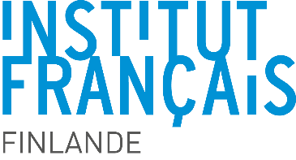
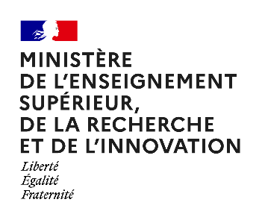

Maupertuis 2023

Higher Education, Research and Innovation Workshop APPLICATION FORM

PI France
First Name
LAST NAME
Professional Email
Alternative email address
Phone Number(s)
Organisation/University
Research department
Laboratory
Position
Have you or your university/laboratory already benefited from a Maupertuis grant, and if so, when?
What were the outcomes?

PI Finland
First Name
LAST NAME
Professional Email
Alternative email address
Phone Number(s)
Organisation/University
Research department
Laboratory
Position
Have you or your university/laboratory already benefited from a Maupertuis grant, and if so, when?
What were the outcomes?

Workshop
Workshop Title
Location
Provisional dates
Expected number of participants
Expected number of young researchers participating (PhD students and Postdocs)
Total budget including other sources of funding
Requested grant from Maupertuis
Organisation/University
Research department
Laboratory

- Presentation of the common scientific collaboration between PIs

- Objectives of the workshop

- Foreseen overall program of the workshop and expected outcomes

  - Higher Education

  - Research

  - Innovation

- List of proposed participants (with institutions)

Please add to this application file
- Short CV (max 2 pages) of the PIs with major publications and awards
- Overall detailed budget including other sources of funding

Merge all documents into one single pdf file which should not exceed 5Mb

Send it by September 30th, 2022, to uniscience.iff@france.fi

