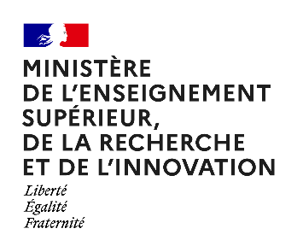

Maupertuis 2023

Researcher Short Mobility programme
APPLICATION FORM

Outgoing Researcher
First Name
LAST NAME
Professional Email
Alternative email address
Phone Number(s)
Organisation/University
Research department
Laboratory
Status (PhD student, Post Doc, Researcher, etc)
If a PhD student: PhD adviser name(s)
Expected date for the end of the PhD or year of completion
Professional address
Street Address
Address Line 2
City Zip Code
Country
Research field
Have you already benefited from a Maupertuis grant, and if so, when? What were the outcomes?

Host Researcher
First Name
LAST NAME
Professional Email
Alternative email address
Phone Number(s)
Position
Organisation/University
Research department
Laboratory

- Presentation of your current research

- Working plan of the visit

- Objectives for the visit
- Scientific:

- Collaborative:

- Education:

- Business (if any):

- Provisional dates and duration of the visit

Please add to this application file
- your updated CV
- Short biography of the outgoing researcher (200 words maximum)
- Short biography of the hosting researcher (200 words maximum)
- Invitation letter from the hosting institution / department
- Motivation letter

Merge all documents into one single pdf file which should not exceed 5Mb

Send it by September 30th, 2022, to uniscience.iff@france.fi

